WEEK 3 DAY 5-OCT 23 (FRIDAY)
ROUTING
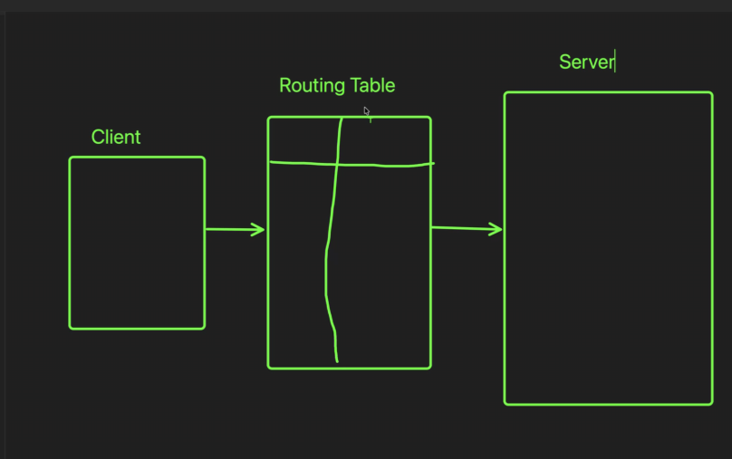
COMP=Ccomponent
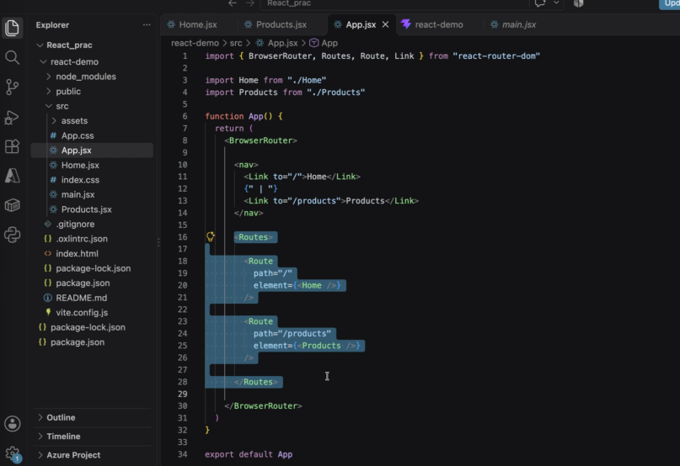
Element = component name
Nav has the link to the path
Path linked to the component
“create a new project” –
npm create vite@latest react-router-demo -- --template react
RAECT ROUTER DEMO
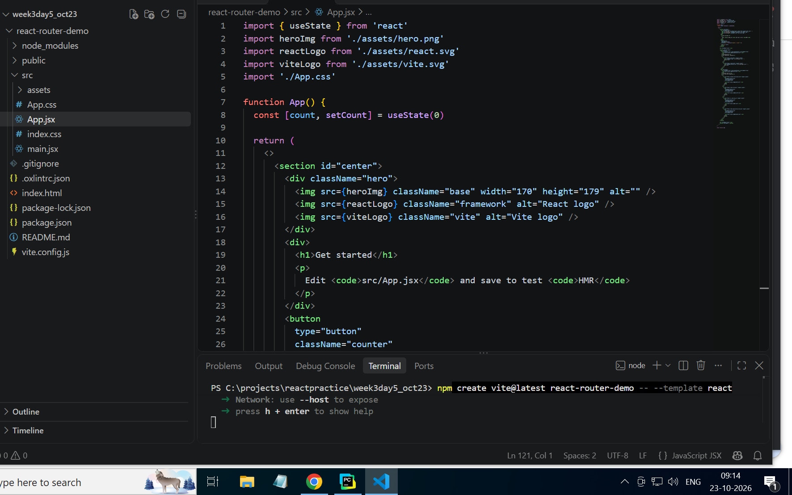
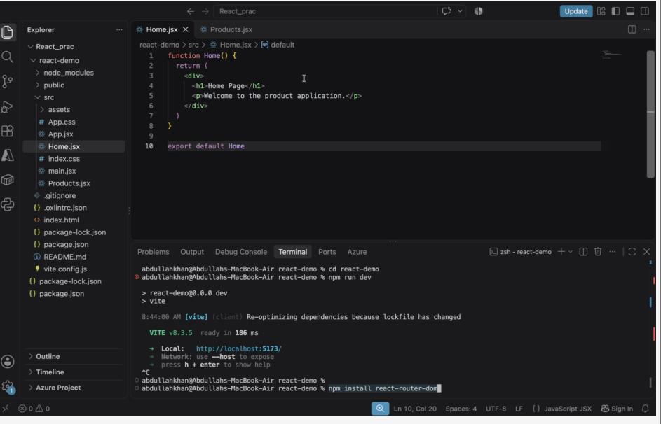
npm install react-router-dom
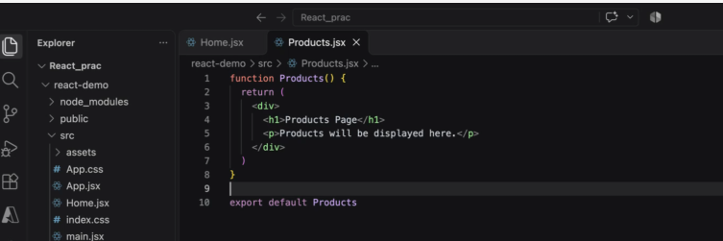
App.jsx code:
import { BrowserRouter, Routes, Route, Link } from "react-router-dom"

import Home from "./Home"
import Products from "./Products"

function App() {
return (
<BrowserRouter>

<nav>
<Link to="/">Home</Link>
{" | "}
<Link to="/products">Products</Link>
</nav>

<Routes>

<Route
path="/"
element={<Home />}
/>

<Route
path="/products"
element={<Products />}
/>

</Routes>

</BrowserRouter>
)
}

export default App
Products.jsx code:
function Products() {
return (
<div>
<h1>Products Page</h1>
<p>Products will be displayed here.</p>
</div>
)
}
export default Products
Home.jsx code:
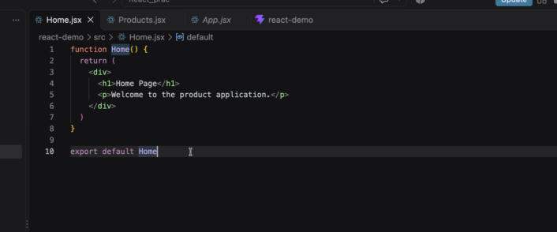
function Home() {
return (
<div>
<h1>Home Page</h1>
<p>Welcome to the product application.</p>
</div>
)
}
export default Home
output:
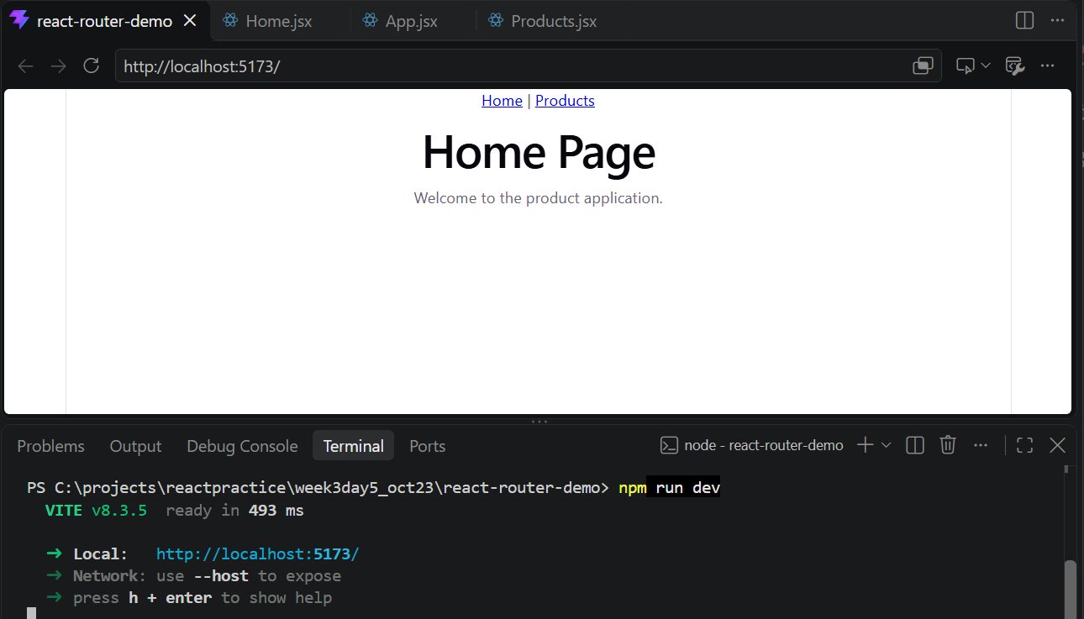
Now Add a link, Route , about component. Create a newncomponen and say it’s the about component.
Changes in code files for doing this:
App.jsx:
function About() {
return (
<div>
<h1>About Page</h1>
<p>This is the About component.</p>
</div>
)
}

export default About
Home.jsx:
function Home() {
return (
<div>
<h1>Home Page</h1>
<p>Welcome to the product application.</p>
</div>
)
}

export default Home
App.jsx:
import { BrowserRouter, Routes, Route, Link } from "react-router-dom"
import About from "./About"
import Home from "./Home"
import Products from "./Products"

function App() {
return (
<BrowserRouter>

<nav>
<Link to="/">Home</Link>
{" | "}
<Link to="/products">Products</Link>
{" | "}
<Link to="/about">About</Link>
</nav>
<Routes>

<Route
path="/"
element={<Home />}
/>
<Route
path="/about"
element={<About />}
/>

<Route
path="/products"
element={<Products />}
/>

</Routes>

</BrowserRouter>
)
}

export default App
Products.jsx: same code

Dynamic route parameter “:id”
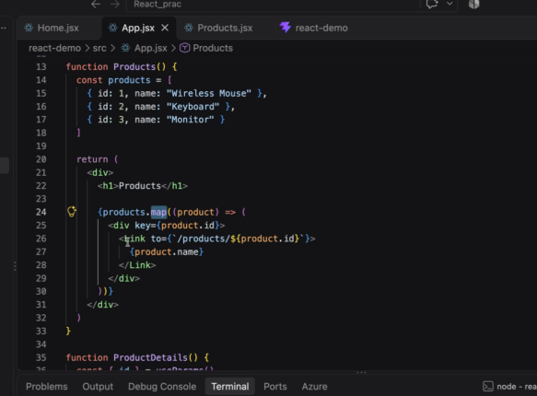
Modified app.jsx:
import {
BrowserRouter,
Routes,
Route,
Link,
useParams
} from "react-router-dom"

function Home() {
return <h1>Home</h1>
}

function Products() {
const products = [
{ id: 1, name: "Wireless Mouse" },
{ id: 2, name: "Keyboard" },
{ id: 3, name: "Monitor" }
]

return (
<div>
<h1>Products</h1>

{products.map((product) => (
<div key={product.id}>
<Link to={`/products/${product.id}`}>
{product.name}
</Link>
</div>
))}
</div>
)
}

function ProductDetails() {
const { id } = useParams()

return (
<div>
<h1>Product Details</h1>
<p>Product ID: {id}</p>
</div>
)
}

function About() {
return <h1>About</h1>
}

function App() {
return (
<BrowserRouter>
<nav>
<Link to="/">Home</Link>
{" | "}
<Link to="/products">Products</Link>
{" | "}
<Link to="/about">About</Link>
</nav>

<Routes>
<Route path="/" element={<Home />} />
<Route path="/products" element={<Products />} />
<Route path="/products/:id" element={<ProductDetails />} />
<Route path="/about" element={<About />} />
</Routes>
</BrowserRouter>
)
}

export default App
next task:
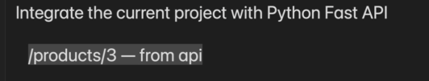
Main.py:
from fastapi import FastAPI
app = FastAPI()
products = {
1: {
"id": 1,
"name": "Wireless Mouse",
"price": 500
},
2: {
"id": 2,
"name": "Keyboard",
"price": 800
},
3: {
"id": 3,
"name": "Monitor",
"price": 12000
}
}
@app.get("/products/{id}")
def get_product(id: int):
return products.get(id, {"message": "Product not found"})
roughcan be wrong)
Great. Your next task is to replace the hardcoded product details with data coming from a FastAPI backend.
Goal
Current URL:
/products/3
Currently shows:
const { id } = useParams()
<p>Product ID: {id}</p>
Instead, it should call:
http://localhost:8000/products/3
and display the product returned by FastAPI.

Step 1: Create FastAPI Backend
Create a folder:
backend
│
└── main.py
Install FastAPI:
pip install fastapi uvicorn
main.py
from fastapi import FastAPI
app = FastAPI()
products = {
1: {
"id": 1,
"name": "Wireless Mouse",
"price": 500
},
2: {
"id": 2,
"name": "Keyboard",
"price": 800
},
3: {
"id": 3,
"name": "Monitor",
"price": 12000
}
}
@app.get("/products/{id}")
def get_product(id: int):
return products.get(id, {"message": "Product not found"})

Step 2: Run FastAPI
uvicorn main:app --reload
Output:
http://127.0.0.1:8000
Test:
http://127.0.0.1:8000/products/3
Response:
{
"id": 3,
"name": "Monitor",
"price": 12000
}

Step 3: Enable React Access
Install CORS support:
pip install fastapi[all]
Update main.py:
from fastapi import FastAPI
from fastapi.middleware.cors import CORSMiddleware
app = FastAPI()
app.add_middleware(
CORSMiddleware,
allow_origins=[""],
allow_credentials=True,
allow_methods=[""],
allow_headers=["*"],
)

Step 4: Update ProductDetails Component
Add imports:
import { useParams } from "react-router-dom"
import { useEffect, useState } from "react"
Replace existing ProductDetails:
function ProductDetails() {
const { id } = useParams()
const [product, setProduct] = useState(null)
useEffect(() => {
fetch(http://localhost:8000/products/${id})
.then(res => res.json())
.then(data => setProduct(data))
}, [id])
if (!product) {
return <h2>Loading...</h2>
}
return (
<div>
<h1>Product Details</h1>
<p>ID : {product.id}</p>
<p>Name : {product.name}</p>
<p>Price : ₹{product.price}</p>
</div>
)
}

Step 5: Keep Routes Same
<Route
path="/products/:id"
element={<ProductDetails />}
/>

Flow Diagram
User Clicks Monitor
|
v
/products/3
|
v
useParams()
|
v
id = 3
|
v
fetch("http://localhost:8000/products/3")
|
v
FastAPI
|
v
{
"id":3,
"name":"Monitor",
"price":12000
}
|
v
React UI Updated
Expected Output
When user clicks Monitor:
Product Details

ID : 3
Name : Monitor
Price : ₹12000
Interview Question
What is :id in React Router?
:id is a dynamic route parameter that captures a value from the URL.
Example:
<Route
path="/products/:id"
element={<ProductDetails />}
/>
URLs:
/products/1
/products/2
/products/3
Retrieve value using:
const { id } = useParams()
For /products/3, id becomes:
3
This is exactly how React Router and FastAPI are commonly integrated in real-world applications.
Post coffee break-
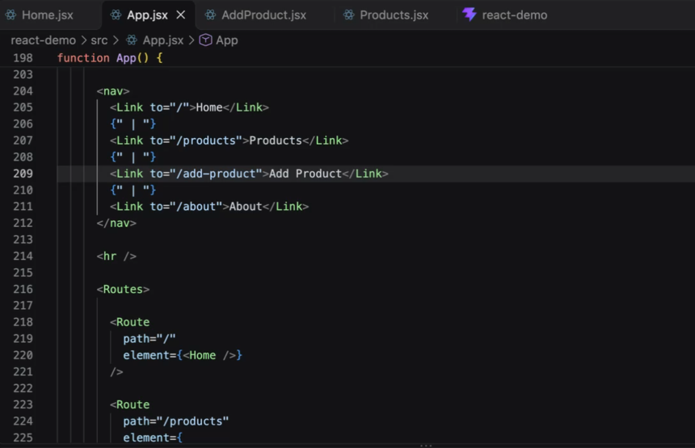
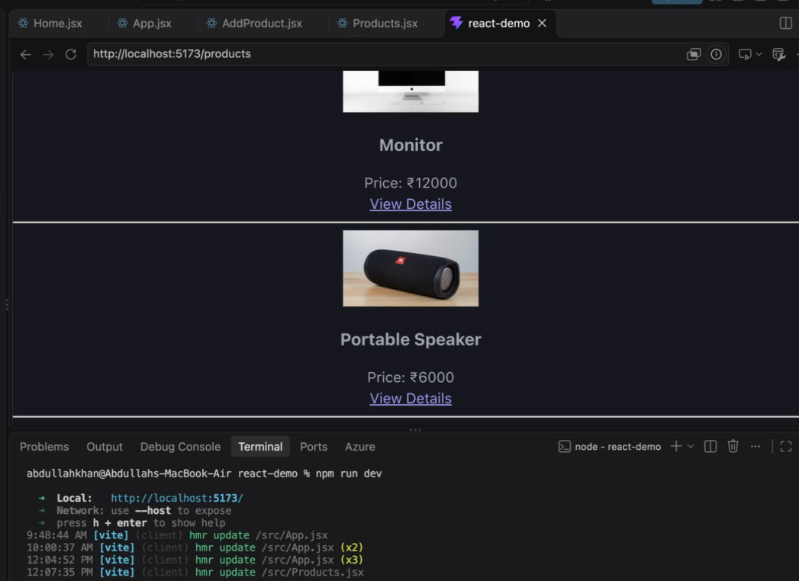
https://images.unsplash.com/photo-1608043152269-423dbba4e7e1
FINAL CODE FOR DEMO:
Home.jsx:
import { Link } from "react-router-dom"

function Home() {
return (
<div>
<h1>Product Store</h1>
<p>Browse the catalog or add a product to the collection.</p>
<p>
<Link to="/products">Browse products</Link>
{" | "}
<Link to="/products/new">Add a product</Link>
</p>
</div>
)
}

export default Home

About.jsx:
function About() {
return (
<div>
<h1>About Page</h1>
<p>This is the About component.</p>
</div>
)
}

export default About

App.jsx:
import { BrowserRouter, Routes, Route, Link } from "react-router-dom"
import About from "./About.jsx"
import AddProduct from "./AddProduct.jsx"
import Home from "./Home.jsx"
import Products, { ProductDetails } from "./Products.jsx"

function App() {
return (
<BrowserRouter>
<nav>
<Link to="/">Home</Link>
{" | "}
<Link to="/products">Products</Link>
{" | "}
<Link to="/products/new">Add Product</Link>
{" | "}
<Link to="/about">About</Link>
</nav>

<Routes>
<Route path="/" element={<Home />} />
<Route path="/products" element={<Products />} />
<Route path="/products/new" element={<AddProduct />} />
<Route path="/products/:id" element={<ProductDetails />} />
<Route path="/about" element={<About />} />
</Routes>
</BrowserRouter>
)
}

export default App

Products.jsx:
import { useEffect, useState } from "react"
import { Link, useParams } from "react-router-dom"
import { DEFAULT_PRODUCT_IMAGE, getProduct, getProducts } from "./api.js"

function Products() {
const [products, setProducts] = useState([])
const [error, setError] = useState("")

useEffect(() => {
getProducts()
.then(setProducts)
.catch((requestError) => setError(requestError.message))
}, [])

return (
<div>
<h1>Products</h1>
{error && <p role="alert">{error}</p>}
{!error && products.length === 0 && <p>Loading products...</p>}
<div>
{products.map((product) => (
<article key={product.id}>
<Link to={`/products/${product.id}`}>
<img
src={product.image || DEFAULT_PRODUCT_IMAGE}
alt={product.name}
width="240"
height="160"
style={{ objectFit: "cover" }}
/>
<h2>{product.name}</h2>
</Link>
<p>₹{product.price}</p>
</article>
))}
</div>
</div>
)
}

export function ProductDetails() {
const { id } = useParams()
const [result, setResult] = useState({ id: null, product: null, error: "" })

useEffect(() => {
let active = true
getProduct(id)
.then((product) => {
if (active) setResult({ id, product, error: "" })
})
.catch((requestError) => {
if (active) setResult({ id, product: null, error: requestError.message })
})

return () => {
active = false
}
}, [id])

if (result.id !== id) return <p>Loading product...</p>
if (result.error) return <p role="alert">{result.error}</p>
const { product } = result

return (
<article>
<h1>{product.name}</h1>
<img
src={product.image || DEFAULT_PRODUCT_IMAGE}
alt={product.name}
width="360"
height="240"
style={{ objectFit: "cover" }}
/>
<p>Product ID: {product.id}</p>
<p>Price: ₹{product.price}</p>
<Link to="/products">Back to products</Link>
</article>
)
}

export default Products

AddProduct.jsx:
import { useState } from "react"
import { useNavigate } from "react-router-dom"
import { createProduct, DEFAULT_PRODUCT_IMAGE } from "./api.js"

function AddProduct() {
const navigate = useNavigate()

const [name, setName] = useState("")
const [price, setPrice] = useState("")
const [image, setImage] = useState(DEFAULT_PRODUCT_IMAGE)
const [error, setError] = useState("")
const [isSaving, setIsSaving] = useState(false)

async function saveProduct(event) {
event.preventDefault()
setError("")
setIsSaving(true)

try {
await createProduct({ name, price: Number(price), image })
navigate("/products")
} catch (requestError) {
setError(requestError.message)
} finally {
setIsSaving(false)
}
}

return (
<div>
<h1>Add Product</h1>

<form onSubmit={saveProduct}>
<input
type="text"
placeholder="Product Name"
value={name}
onChange={(e) => setName(e.target.value)}
required
/>

<br />

<input
type="number"
placeholder="Price"
value={price}
onChange={(e) => setPrice(e.target.value)}
min="0.01"
step="0.01"
required
/>

<br />

<input
type="url"
placeholder="Image URL"
value={image}
onChange={(e) => setImage(e.target.value)}
required
/>

<br />

{error && <p role="alert">{error}</p>}
<button type="submit" disabled={isSaving}>
{isSaving ? "Saving..." : "Save Product"}
</button>
</form>
</div>
)
}

export default AddProduct

Main.py (backend file):
from fastapi import FastAPI, HTTPException
from fastapi.middleware.cors import CORSMiddleware
from pydantic import BaseModel
import psycopg2

app = FastAPI()

app.add_middleware(
CORSMiddleware,
allow_origins=["*"],
allow_credentials=True,
allow_methods=["*"],
allow_headers=["*"],
)

class Product(BaseModel):
id: int
name: str
price: float
image: str

def get_connection():
return psycopg2.connect(
host="localhost",
database="product_store",
user="postgres",
password="Admin@123"
)

@app.get("/")
def home():
return {"message": "FastAPI Running"}

@app.get("/products")
def get_products():

conn = get_connection()
cursor = conn.cursor()

cursor.execute("""
SELECT id, name, price, image
FROM products
ORDER BY id
""")

rows = cursor.fetchall()

cursor.close()
conn.close()

products = []

for row in rows:
products.append({
"id": row[0],
"name": row[1],
"price": float(row[2]),
"image": row[3]
})

return products

@app.post("/products")
def create_product(product: Product):

conn = get_connection()
cursor = conn.cursor()

cursor.execute(
"""
INSERT INTO products(id,name,price,image)
VALUES (%s,%s,%s,%s)
""",
(
product.id,
product.name,
product.price,
product.image
)
)

conn.commit()

cursor.close()
conn.close()

return {"message": "Product added successfully"}

@app.put("/products/{product_id}")
def update_product(product_id: int, product: Product):

conn = get_connection()
cursor = conn.cursor()

cursor.execute(
"""
UPDATE products
SET name=%s,
price=%s,
image=%s
WHERE id=%s
""",
(
product.name,
product.price,
product.image,
product_id
)
)

conn.commit()

cursor.close()
conn.close()

return {"message": "Product updated successfully"}

@app.delete("/products/{product_id}")
def delete_product(product_id: int):

conn = get_connection()
cursor = conn.cursor()

cursor.execute(
"""
DELETE FROM products
WHERE id=%s
""",
(product_id,)
)

conn.commit()

cursor.close()
conn.close()

return {"message": "Product deleted successfully"}
output:
